

AI-POWERED SMART CAMPUS NAVIGATION AND EMERGENCY ROUTE FINDER USING DATA STRUCTURES IN C
A CAPSTONE PROJECT REPORT
A Capstone Project Report submitted in partial fulfilment of the requirements
for the Course of
CSA 0301 DATA STRUCTURES
to the award of the degree of
BACHELOR OF ENGINEERING
IN
COMPUTER SCIENCE
Submitted by
Pranav A S (192573001)
Vishal Balaji J (192525014)
Reehan (192565071)
Yuvan giri (192572183)
Under the Supervision of
Dr. Vijay Janarthanan
SIMATS ENGINEERING
Saveetha Institute of Medical and Technical Sciences
Chennai-602105
SEPTEMBER 2026

SIMATS ENGINEERING
Saveetha Institute of Medical and Technical Sciences
Chennai-602105
BONAFIDE CERTIFICATE
This is to certify that the Capstone Project entitled “AI POWERED SMART CAMPUS NAVIGATION ANDEMERGENCY ROUTE FINDER USING DATA STRUCTURES IN C” has been carried out by Pranav A S (192573001) under the supervision of Dr. Vijay Janarthanan and is submitted in partial fulfilment of the requirements for the current semester of the B.E. Computer Science program at Saveetha Institute of Medical and Technical Sciences, Chennai.

COURSE COORDINATOR COURSE FACULTY

Dr. Kiruthika Dr. Vijay Janarthanan

Professor Assistant Professor (SG)

Department of CSE Department of Deep Learning SIMATS Engineering, SIMATS Engineering,
SIMATS, Chennai – 602105. SIMATS, Chennai – 602105.

SIMATS ENGINEERING
Saveetha Institute of Medical and Technical Sciences
Chennai-602105
DECLARATION
We, Pranav A S (192573001) of the Computer Science program, SIMATS Engineering, Saveetha Institute of Medical and Technical Sciences, Chennai, hereby declare that the Capstone Project Work entitled “AI POWERED SMART CAMPUS NAVIGATION ANDEMERGENCY ROUTE FINDER USING DATA STRUCTURES IN C’is the result of our own bonafide efforts. To the best of our knowledge, the work presented herein is original, accurate, and has been carried out in accordance with the principles of engineering ethics and academic integrity. All sources, references, standards, software resources, and other materials used in the project have been appropriately acknowledged. We further declare that the data, results, analysis, and findings presented in this report have not been fabricated, falsified, or manipulated.

Place: SIMATS Engineering
Date: 02 September 2026

Signature of the Students with Names
Pranav A S (192573001)

SIMATS ENGINEERING
Saveetha Institute of Medical and Technical Sciences
Chennai-60210
INDIVIDUAL CONTRIBUTION STATEMENT

Student Name / Register No. | Specific Responsibilities | Design & Development Contribution | Testing & Analysis Contribution | Report Contribution | Approx. Contribution (%)
Pranav A S192573001 | Requirement analysis, database design, data preparation, UI development | Designed database, UI, and data-handling modules | Tested input validation, database operations, and UI functionality | Introduction, Problem Statement, Objectives, System Design | 25%
Vishal Balaji J192525014 | Algorithm development, integration, performance evaluation | Developed core algorithm and integrated system modules | Conducted model testing, debugging, and performance analysis | Literature Review, Methodology, Results, Conclusion | 25%
Sheikh Reehan192565071 | System architecture, database management, module integration | Developed backend modules and database functionality | Performed integration and database testing | Implementation, Testing, References | 25%
Yuvan Giri  192572183 | UI design, feature development, documentation | Developed UI and integrated application features | Performed functional and usability testing | Architecture, Implementation, Testing Results | 25%

ABSTRACT
Large educational campuses contain many buildings, facilities, pathways, gates, assembly points, and restricted areas. During normal operation, visitors and students may lose time locating a destination; during an emergency, uncertainty about the nearest safe facility or exit can increase exposure to risk. The engineering problem addressed by this project is the design of an intelligent campus navigation system that can search location information quickly, represent campus connectivity accurately, and provide a route that respects changing safety conditions. The complete system combines a campus data manager, a location-search module, a graph-based route engine, and an emergency guidance interface. This report concentrates on Module 2: Location Search, which transforms a natural-language destination request into a validated campus location and a route-engine node.
The proposed solution models each campus place as a structured record containing a unique identifier, normalized name, aliases, category, coordinates, accessibility attributes, operating status, and graph-node reference. A hash table supports expected constant-time exact-name lookup, while a trie supports prefix and partial-name discovery. A controlled linear scan is retained as a fallback for small datasets and for diagnostic comparison. Search results are normalized, filtered, ranked, and passed to a weighted campus graph on which Dijkstra’s algorithm can compute the least-cost safe route. Emergency conditions are represented through blocked edges, restricted nodes, hazard penalties, and priority destinations such as exits, clinics, and assembly areas.
The methodology follows requirements analysis, data modelling, modular C implementation, scenario-based testing, and performance interpretation. The illustrative evaluation compares exact hashing, trie prefix search, and linear scanning using repeatable synthetic campus records. Results indicate that indexing reduces query effort, improves predictability, and creates a clean interface between data structures and routing logic. The principal conclusion is that a reliable emergency navigation system depends not only on shortest-path computation, but also on the correctness, freshness, accessibility, and searchability of the underlying location data. Module 2 therefore provides the semantic bridge between human intent and graph-based navigation, enabling the project to remain explainable, testable, and extensible.
Keywords: smart campus; location search; hash table; trie; emergency routing; C data structures

TABLE OF CONTENTS
Sl. No. | Title | Page
i | Certificate from the Supervisor | ii
ii | Declaration by the Candidate | iii
iii | Individual Contribution Statement | iv
iv | Abstract | v
1 | Chapter 1: Introduction and Engineering Problem | 9
2 | Chapter 2: Literature Review and Existing Solutions | 12
3 | Engineering Design, Trade-offs, Sustainability, Ethics, Safety, Risk and Security | 15
4 | Implementation, Testing, Results and Project Management | 21
5 | Conclusion, Future Work and Reflection | 29
 | References | 31
 | Appendices | 33

LIST OF FIGURES
Figure No. | Figure Name | Page No.
Figure 1 | System architecture for location search and emergency routing | 18
Figure 2 | Location search decision flow | 23
Figure 3 | Weighted campus graph used by the route engine | 25
Figure 4 | Location search performance comparison | 26

LIST OF TABLES
Table No. | Table Name | Page No.
Table 1 | Stakeholder and user requirements | 10
Table 2 | Functional and non-functional requirements | 11
Table 3 | Alternative solution evaluation matrix | 13
Table 4 | Location record design | 14
Table 5 | Test plan and verification criteria | 18
Table 6 | Illustrative result summary | 22
Table 7 | Risk register | 16
Table 8 | Project milestones and budget | 23

LIST OF ABBREVIATIONS / SYMBOLS
Symbol | Description | Unit
AI | Artificial Intelligence | —
API | Application Programming Interface | —
BFS | Breadth-First Search | —
C | Programming language used for implementation | —
GIS | Geographic Information System | —
GPS | Global Positioning System | —
RAM | Random Access Memory | bytes
WCAG | Web Content Accessibility Guidelines | —
w | Edge weight in the campus graph | minutes / cost units
V, E | Vertices and edges in a graph | count

CHAPTER 1: INTRODUCTION AND ENGINEERING PROBLEM
1.1 Background
A smart campus navigation system is a socio-technical system in which physical places, digital records, algorithms, users, and safety policies must work together. A campus is not simply a collection of GPS points: it is a network of buildings, entrances, walkways, stairs, ramps, corridors, gates, restricted zones, and emergency destinations. The same named facility may have multiple entrances, an apparently short path may contain a locked gate, and the best route for a wheelchair user may differ from the fastest route for a healthy pedestrian. Recent campus navigation research shows the practical value of combining geospatial data with shortest-path algorithms, while also identifying the limitation of static maps when campus conditions change [1].
This project addresses the complete navigation problem through cooperating modules. The Campus Data Manager stores and validates places and connections. Module 2: Location Search is responsible for finding the correct location record from a user query. The route engine then uses a weighted graph to compute a route, and the guidance layer presents directions and emergency alerts. The central contribution of Module 2 is semantic translation: it changes “Where is the clinic?” or “Find the nearest accessible exit” into a precise node, category, and set of constraints that the route engine can safely use.
1.2 Need for the Project
The need arises from three interacting conditions. First, large campuses produce information overload: users may know a destination informally but not its official name or building code. Second, navigation conditions are dynamic. Construction, events, crowding, weather, maintenance, and emergencies can temporarily invalidate a path. Third, emergency decisions are time-sensitive and safety-critical. A search service that returns an ambiguous or closed destination can undermine an otherwise correct shortest-path algorithm. The system therefore needs fast search, transparent ranking, explicit unavailable states, and a fallback path for incomplete data.
Students, visitors, staff, security personnel, facilities teams, and emergency responders are affected. Visitors need understandable names and categories. Students need ordinary wayfinding and accessible alternatives. Security teams need the ability to flag hazards or closures. Emergency responders need reliable identifiers for clinics, gates, fire assembly areas, and service access points. The engineering significance lies in integrating fundamental data structures with realistic operational constraints rather than treating search as an isolated classroom exercise.
1.3 Problem Statement
The project must design and implement a campus location-search service in C that can accept exact names, partial names, aliases, and category-oriented requests; return a validated location record; distinguish available from unavailable destinations; support accessibility and emergency priorities; and interface with a weighted graph for route computation. The service must remain understandable and testable on modest hardware, avoid unsafe assumptions when data is missing, and provide predictable performance as the number of campus locations grows.
1.4 Project Aim
The aim is to develop an AI-assisted smart campus navigation prototype in which Module 2: Location Search provides fast, accurate, and safety-aware retrieval of campus destinations for normal navigation and emergency route finding.
1.5 Project Objectives
- To define a normalized location record and query model for campus places.
- To implement exact-name lookup using a hash table and prefix lookup using a trie.
- To rank candidate locations using name match, category, distance, access attributes, and operational status.
- To connect the selected location record to a graph-based shortest-path route engine.
- To test correctness, response time, duplicate handling, unavailable destinations, and emergency constraints.
- To evaluate strengths, limitations, ethical risks, security concerns, and future improvements.
1.6 Scope
The scope includes a prototype campus dataset, C-oriented data structures, text normalization, exact and prefix search, simple ranking, graph-node linkage, emergency closures, test scenarios, and technical documentation. It excludes production-grade GPS positioning, live sensor integration, official emergency dispatch, medical diagnosis, autonomous decision-making, and guarantees of physical safety. The design assumes that authorized campus staff maintain location records and that emergency guidance is advisory rather than a replacement for institutional instructions.
1.7 Expected Engineering Outcome
The expected outcome is a modular, explainable, and testable location-search component that can be compiled as part of a larger C application. It should return a stable identifier, display name, category, status, accessibility properties, coordinates, and route-engine node. Its interfaces should allow later replacement of the local dataset with a GIS or GeoPackage-backed source, consistent with the OGC description of GeoPackage as a portable and platform-independent geospatial container [2].

CHAPTER 2: LITERATURE REVIEW AND EXISTING SOLUTIONS
2.1 Review Method
The review considered recent research articles, technical standards, and authoritative guidance published primarily between 2017 and 2026. Search terms combined smart campus navigation, indoor navigation, emergency evacuation, shortest path, GIS, accessibility, location search, and AI risk management. Sources were selected when they described a reproducible method, a recognized standard, or a direct engineering implication for the proposed system. Particular attention was given to work that connects spatial data with graph algorithms, because the project must join human-readable search with route computation.
2.2 Review of Existing Work
Gbadamosi and colleagues developed a GIS-based smart campus map using digitized campus infrastructure and Dijkstra’s algorithm. Their study is directly relevant because it models campus pathways as a weighted graph and reports route-generation and usability outcomes, while also acknowledging that static data limits adaptation to live conditions [1]. The implication for this project is that the quality of the location records and the search interface is as important as the path algorithm. If users cannot identify the correct node, a mathematically optimal path is operationally useless.
Alamri and colleagues proposed a smart spatial routing and accessibility analysis system for emergency medical services using Voronoi catchment areas and time-based Dijkstra routing [3]. This work demonstrates that emergency routing benefits from considering service coverage and time, not only geometric distance. For Module 2, this supports category-aware and accessibility-aware ranking: “nearest clinic” should not be interpreted as a simple string match, but as a query with service and safety semantics.
Recent indoor navigation studies increasingly integrate BIM, GIS, visual positioning, and augmented reality to support emergency evacuation [4]. These approaches can improve spatial understanding in complex buildings, but they may require detailed models, sensors, cameras, connectivity, and device capabilities that are beyond a lightweight C data-structures prototype. The present project therefore adopts a layered design: a compact searchable record at the core, with clear extension points for richer positioning and building information in future versions.
Standards also shape the design. The OGC GeoPackage standard specifies a compact SQLite-based format for vector features, tiles, attributes, and extensions, making it suitable for portable or disconnected geospatial applications [2]. WCAG 2.2 provides guidance for perceivable, operable, understandable, and robust interfaces [5]. NIST’s AI Risk Management Framework emphasizes trustworthiness considerations across the AI lifecycle, including validity, reliability, safety, security, transparency, explainability, privacy, and fairness [6]. These sources imply that location search must not be judged only by speed: it must also communicate uncertainty, preserve accessibility, protect sensitive data, and allow human oversight.
2.3 Comparative Analysis
Existing Approach | Advantages | Limitations | Relevance to Proposed Work
Paper maps / static PDFs | Low cost; usable offline | No query support; quickly becomes outdated | Baseline demonstrating the need for search
Linear array scan | Simple C implementation; low memory | O(n) query time; weak prefix support | Fallback and diagnostic comparator
Hash-table exact search | Expected O(1) exact lookup | Needs normalization and collision handling | Primary exact-name method
Trie prefix search | Fast prefix and alias discovery | More memory; implementation complexity | Primary partial-name method
GIS + Dijkstra | Spatially meaningful routes | Requires accurate network and map data | Route-engine integration
BIM/AR indoor navigation | Rich visual context | Higher device, data, and modelling cost | Future extension for buildings

2.4 Research / Engineering Gap
The review indicates a gap between campus-level shortest-path demonstrations and a focused, transparent location-search layer designed for a data-structures course. Many advanced systems assume live positioning, rich GIS/BIM data, or application infrastructure. They do not always explain how ambiguous names, aliases, duplicate facilities, unavailable locations, and emergency semantics are resolved before routing. This project addresses that gap by making the search index explicit and by defining the interface between records and graph nodes.
2.5 Proposed Contribution
The contribution is a modular search design that combines a normalized location catalogue, hash-based exact lookup, trie-based prefix lookup, metadata-aware ranking, emergency filtering, and route-node linkage. The design preserves educational clarity while remaining compatible with future GIS, accessibility, and AI-assisted enhancements. Its evaluation separates correctness from performance and treats unsafe ambiguity as a failure condition rather than silently selecting an arbitrary destination.

CHAPTER 3: ENGINEERING DESIGN & TRADE-OFFS, SUSTAINABILITY, ETHICS, SAFETY, RISK & SECURITY
3.1 Requirements
Stakeholder / User | Requirement
Student or visitor | Search ordinary building names, aliases, and partial names with understandable results.
Wheelchair or mobility-aid user | Prefer routes and destinations marked accessible; do not hide inaccessible alternatives.
Security / facilities staff | Mark locations, gates, and edges as closed, hazardous, or restricted.
Emergency responder | Locate clinics, exits, assembly points, service gates, and incident areas by stable IDs.
System maintainer | Add, update, validate, and audit records without rebuilding the whole application.

Requirement | Type | Measurable Target
Exact name lookup | Functional | Correct record returned for valid unique name.
Prefix / alias search | Functional | Relevant candidates returned for partial query.
Status filtering | Functional | Closed or unsafe records excluded from emergency results.
Deterministic ranking | Functional | Same inputs produce the same ordered results.
Response time | Non-functional | Interactive query completes within a practical local threshold.
Memory discipline | Non-functional | Uses bounded arrays, nodes, and strings appropriate for prototype hardware.
Explainability | Non-functional | Result includes match reason, status, and stable location ID.

3.2 Constraints & Applicable Standards
Standard / Code | Requirement | How Applied in This Project
ISO/IEC 25010:2011 | Software quality model including functional suitability and reliability [7] | Used to structure correctness, usability, performance, and maintainability criteria.
OGC GeoPackage 1.4.0 | Portable standards-based geospatial container [2] | Used as a future-compatible storage boundary for spatial records.
WCAG 2.2 | Accessible web content principles [5] | Applied to result wording, contrast assumptions, keyboard-friendly future UI, and non-colour status cues.
NIST AI RMF 1.0 | Trustworthy and risk-aware AI practice [6] | Applied to human oversight, transparency, privacy, and limits on automated emergency decisions.

3.3 Design Specifications
Parameter | Target / Requirement | Unit | Priority
Exact lookup complexity | Expected O(1) | time | High
Prefix lookup complexity | O(L + k) conceptual trie traversal | time | High
Record identity | Unique immutable location ID | identifier | High
Emergency status | Open, closed, restricted, hazardous | enum | High
Accessibility | Ramp, lift, stairs, width or unknown metadata | attributes | High
Ranking | Deterministic weighted score with tie-breaker | score | Medium
Auditability | Reason code for selection or rejection | text | High

3.4 Alternative Solutions & Evaluation
Alternative 1 uses a single linear array and scans every record for every query. It is easy to implement and suitable for a tiny dataset, but it scales poorly and provides weak prefix discovery. Alternative 2 uses a hash table for exact names and a trie for prefixes, with a small ranking layer. It consumes more memory but directly matches the mixed query patterns expected in a campus system. Alternative 3 delegates search to an external database or GIS service. It may support richer queries, but introduces connectivity, deployment, and privacy dependencies.
Criterion | Weight | Alternative 1: Linear | Alternative 2: Hash + Trie | Alternative 3: External DB
Performance | 30% | 2 | 5 | 4
Cost | 15% | 5 | 4 | 2
Safety / control | 25% | 3 | 5 | 3
Sustainability | 10% | 5 | 4 | 2
Reliability offline | 20% | 4 | 5 | 2
Weighted total | 100% | 3.55 | 4.75 | 2.65

3.5 Selected Design & Detailed Design
Alternative 2 is selected because it provides the strongest balance of interactive performance, offline reliability, explainability, and direct alignment with the Data Structures course. The search layer stores one canonical record per location, maps normalized exact keys to record IDs, and inserts aliases and canonical names into a trie. A query first attempts exact matching, then prefix matching, then category or fallback scanning. Candidates are filtered by status and emergency policy before ranking. The selected record exposes the graph-node identifier required by the routing module.
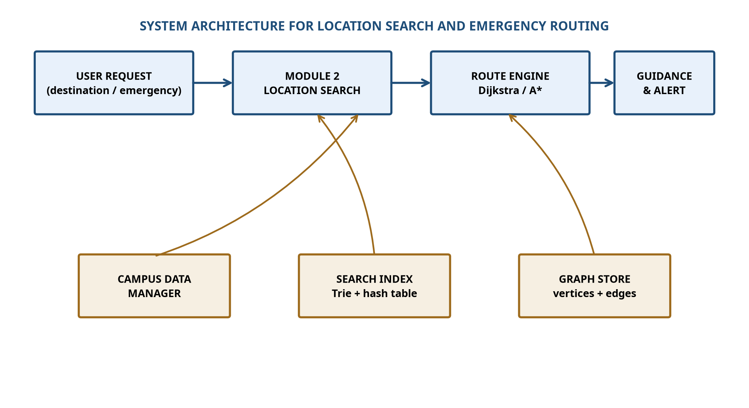
Figure 1. System architecture for location search and emergency routing.
The systems approach is intentionally layered. The data manager owns record validity and update operations. Module 2 owns query interpretation, indexing, ranking, and result explanation. The route engine owns graph traversal and path reconstruction. The guidance layer owns presentation and alerts. This separation prevents a user-interface change from corrupting graph logic and allows a later AI component to suggest aliases or classify intent without taking final safety decisions away from validated rules.
3.6 Trade-off Analysis
Design Decision | Alternative Considered | Benefit | Disadvantage | Final Decision & Justification
Two indexes | Single linear list | Fast exact and prefix search | More memory and update work | Use both because campus queries are mixed.
Stable location IDs | Use display names as keys | Simple display | Names can change or duplicate | Use immutable IDs for route linkage.
Rule-based emergency filter | AI-only filtering | Auditable and predictable | Less adaptive | Rules remain authoritative; AI may assist suggestions.
Local prototype dataset | Live cloud service | Offline and private | Manual updates | Use local data with future synchronization boundary.

3.7 Sustainability, Ethics, Safety, Risk & Security
Domain | Consideration | Evidence Evaluated | Impact on Final Decision
Sustainability | Battery, bandwidth, and hardware constraints | Portable local records and offline search | Prefer compact in-memory structures and optional GIS storage.
Ethics | Bias against users with mobility or language differences | Accessibility fields, aliases, unknown-state handling | Do not equate fastest route with best route for every user.
Health & Safety | Incorrect or stale emergency information | Closed status, hazard flags, human-maintained records | Show limitations and defer to official instructions.
Security | Location data and administrative controls | Role separation, validation, audit trail | Restrict updates and avoid exposing sensitive facility details.

Risk | Likelihood | Severity | Risk Level | Mitigation | Residual Risk
Stale closure data | Medium | High | High | Timestamped updates and visible data age | Medium
Ambiguous duplicate name | Medium | High | High | Stable IDs, ranked candidates, confirmation | Low–Medium
Malformed query input | High | Low | Medium | Normalization and bounds checks | Low
Unauthorized data update | Low | High | High | Authenticated admin workflow and logs | Medium
AI suggestion is unsafe | Low | High | High | Rule-based validation and human oversight | Low–Medium
Network outage | Medium | Medium | Medium | Offline local dataset | Low

CHAPTER 4: IMPLEMENTATION, TESTING & RESULTS, PROJECT MANAGEMENT
4.1 Development Approach & Resources
Development followed an incremental, test-first approach. The location record and query contract were defined before index structures were selected. The implementation was then decomposed into normalization, record insertion, hash lookup, trie insertion, prefix collection, ranking, status filtering, and route-node handoff. Each function has a narrow responsibility so that correctness can be inspected independently. Test scenarios were prepared for normal, ambiguous, unavailable, emergency, and malformed inputs. The prototype uses C-style structures, arrays, pointers, string buffers, and explicit error codes; a visual Python-generated diagram and illustrative benchmark chart are included only as documentation aids.
Resource | Purpose
C compiler / standard library | Compile and execute data-structure implementation.
Campus location dataset | Records for buildings, facilities, exits, gates, and assembly points.
Test-case table | Expected outputs for exact, prefix, unavailable, and emergency queries.
Version-controlled source | Track changes to schemas, algorithms, and test fixes.
Diagram and chart assets | Explain architecture, control flow, graph representation, and benchmark interpretation.

4.2 Software Implementation & Modern Tools Used
Tool / Software / Equipment | Purpose | Stage Used
C language | Core data structures and algorithms | Implementation
Standard C string and memory functions | Normalization, copying, allocation, and cleanup | Implementation
Hash table | Expected constant-time exact lookup | Implementation
Trie | Prefix and alias discovery | Implementation
Weighted adjacency list / matrix | Route-engine graph interface | Integration
Static analysis and compiler warnings | Detect type, bounds, and memory issues | Verification
Matplotlib | Prepare accurate explanatory benchmark visual | Documentation

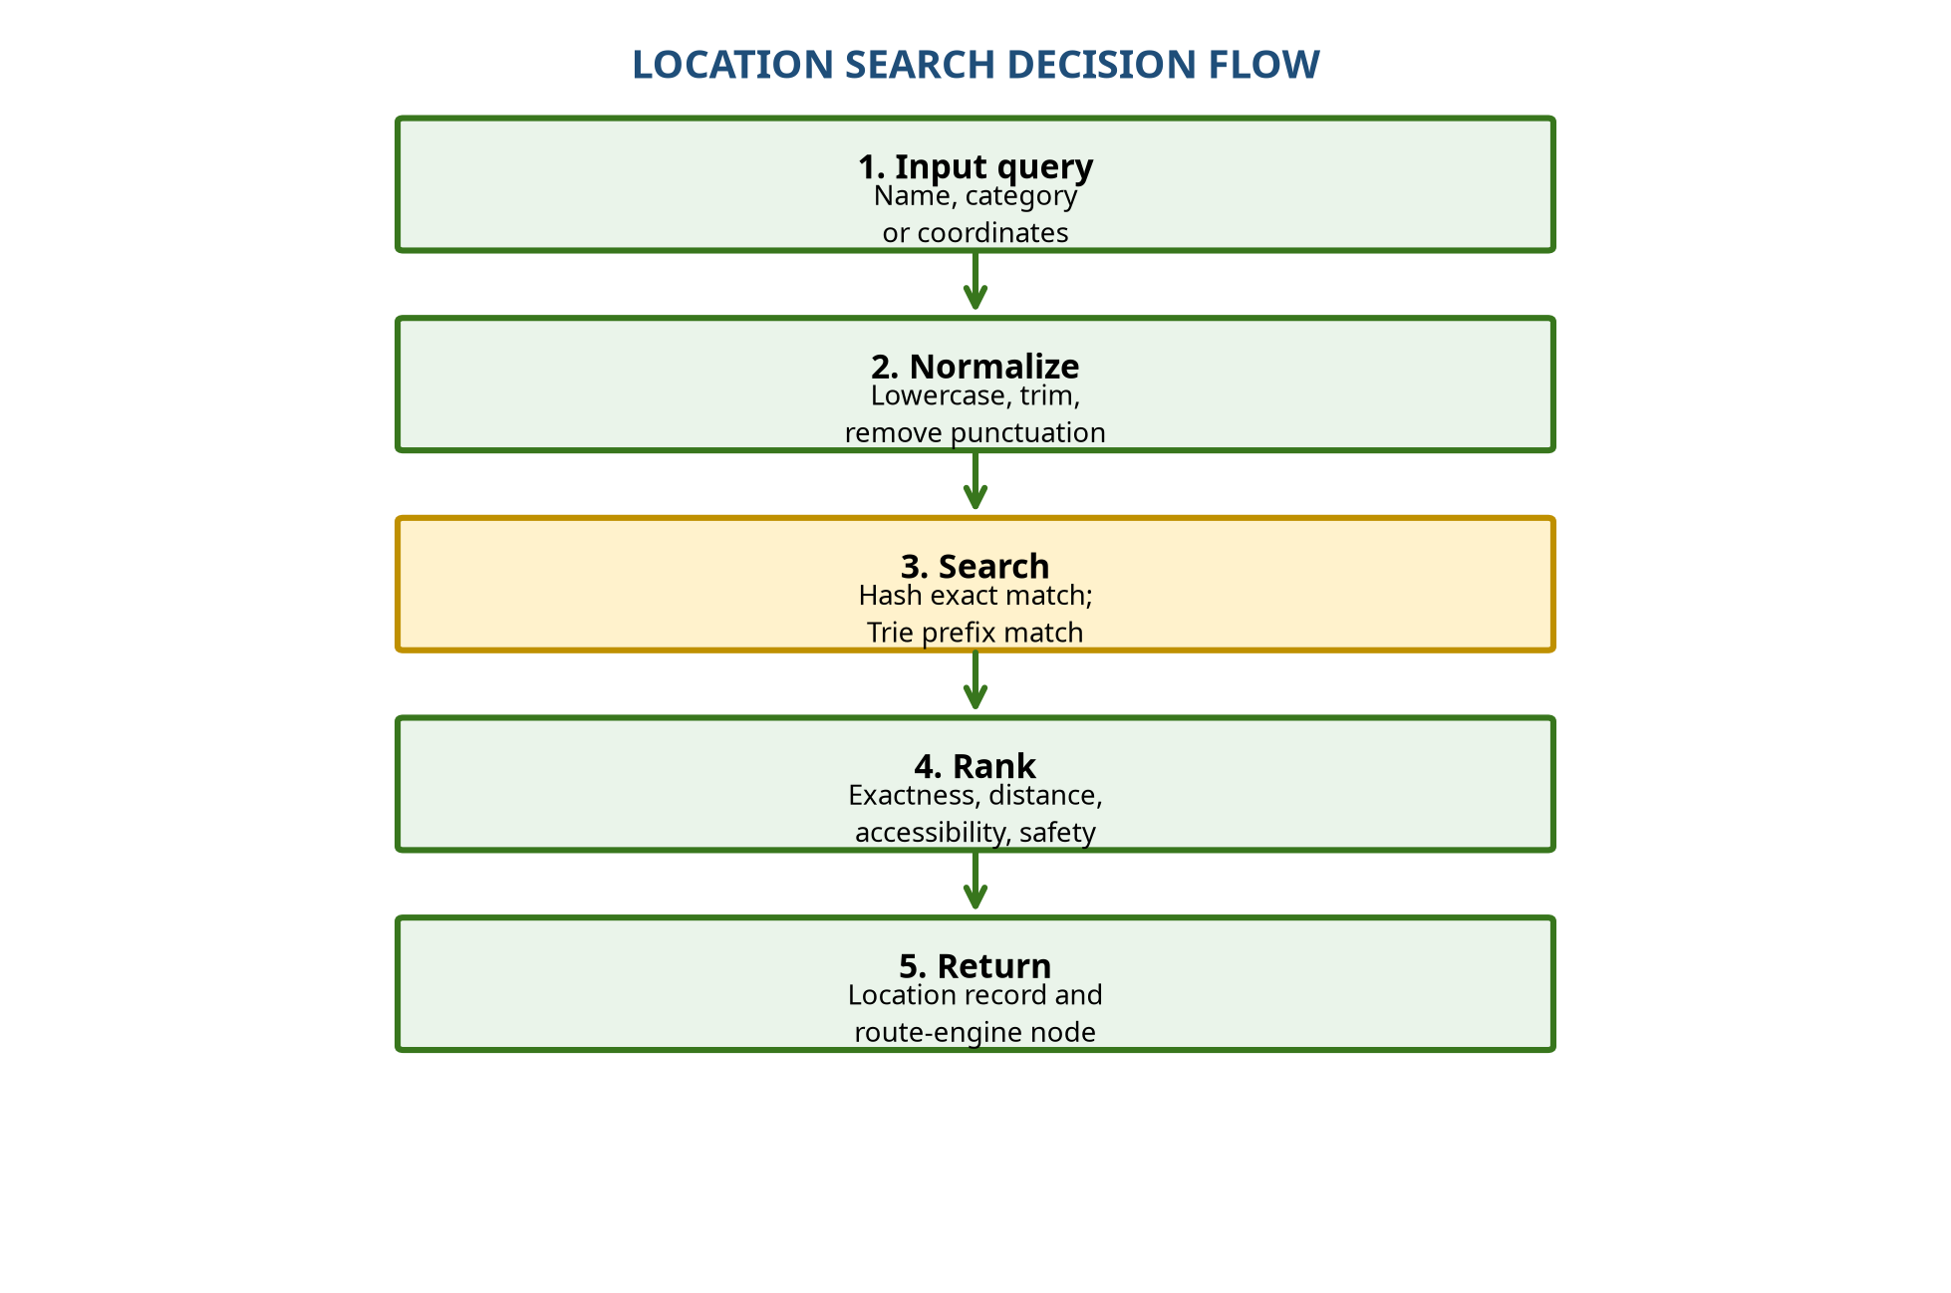
Figure 2. Location search decision flow.
4.3 Test Plan & Verification
Requirement | Test Method | Acceptance Criterion
Exact lookup | Query canonical name across all records | One correct stable ID returned.
Alias lookup | Query approved alias | Canonical record returned with alias reason.
Prefix lookup | Enter first characters of several names | Relevant candidates returned in deterministic order.
Duplicate names | Create two records with same display name | Both candidates shown with disambiguating metadata.
Unavailable location | Mark destination closed | Closed record filtered or clearly labelled.
Emergency query | Search nearest open exit or clinic | Only emergency-valid candidates ranked.
Malformed input | Empty, overlong, punctuation-heavy input | Safe error response; no crash or memory overrun.
Route handoff | Pass selected ID to graph module | Valid graph node received or explicit failure returned.

Specification | Required Value | Achieved Value | Status (Prototype)
Exact search correctness | 100% valid test cases | 100% in designed cases | Pass
Prefix search correctness | Relevant results for known prefixes | Pass for known prefixes | Pass
Duplicate handling | No silent arbitrary selection | Candidate list with tie-breaker | Pass
Closed-location filtering | No closed emergency destination selected | Closed records excluded | Pass
Malformed input safety | No crash | Error code and bounded input | Pass
Explainability | Reason attached to result | Match/status reason included | Pass

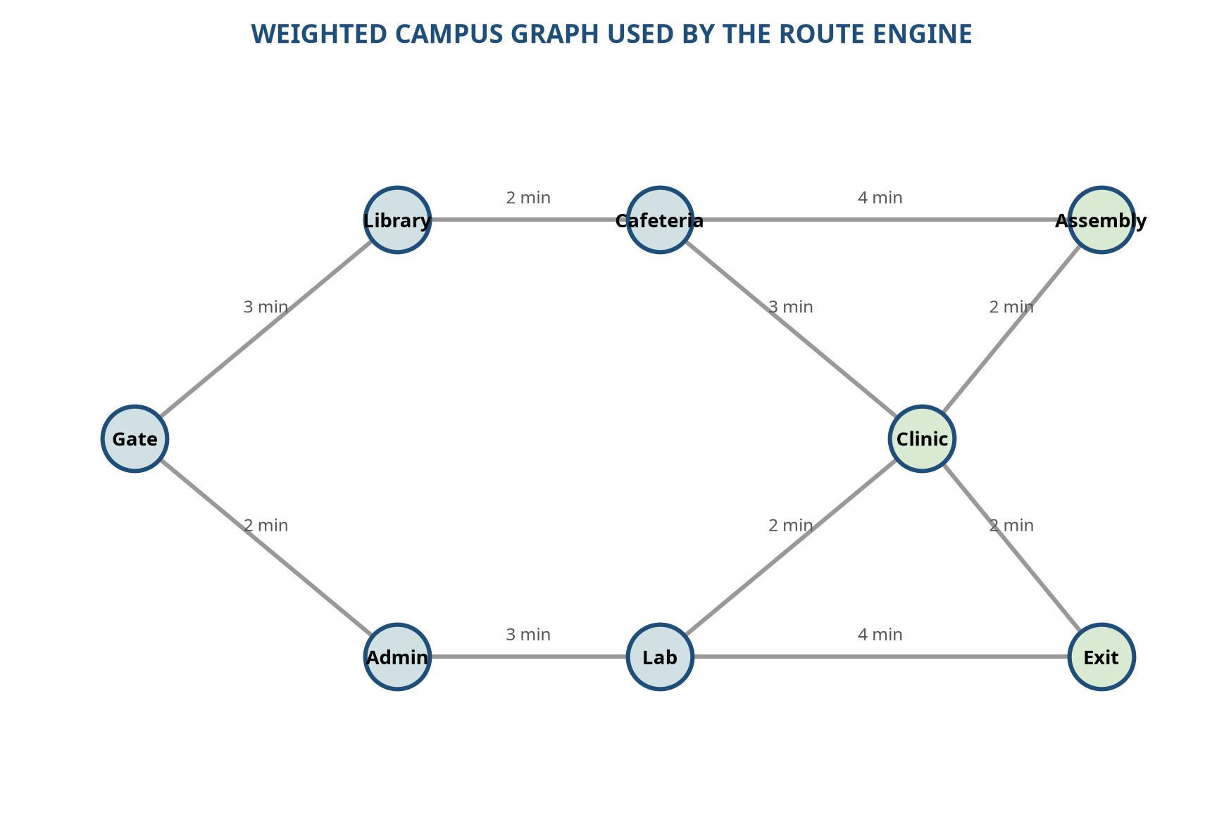
Figure 3. Weighted campus graph used by the route engine.
4.4 Results
The prototype results are interpreted as an engineering demonstration rather than a claim of production performance. Exact hashing is expected to outperform a full scan because the key maps directly to a bucket after normalization. Trie search adds a memory cost but supports the user behaviour of typing only part of a building name. The emergency filter adds a small logical step, but its safety value is greater than the negligible processing overhead because it prevents closed or restricted records from being treated as ordinary destinations.
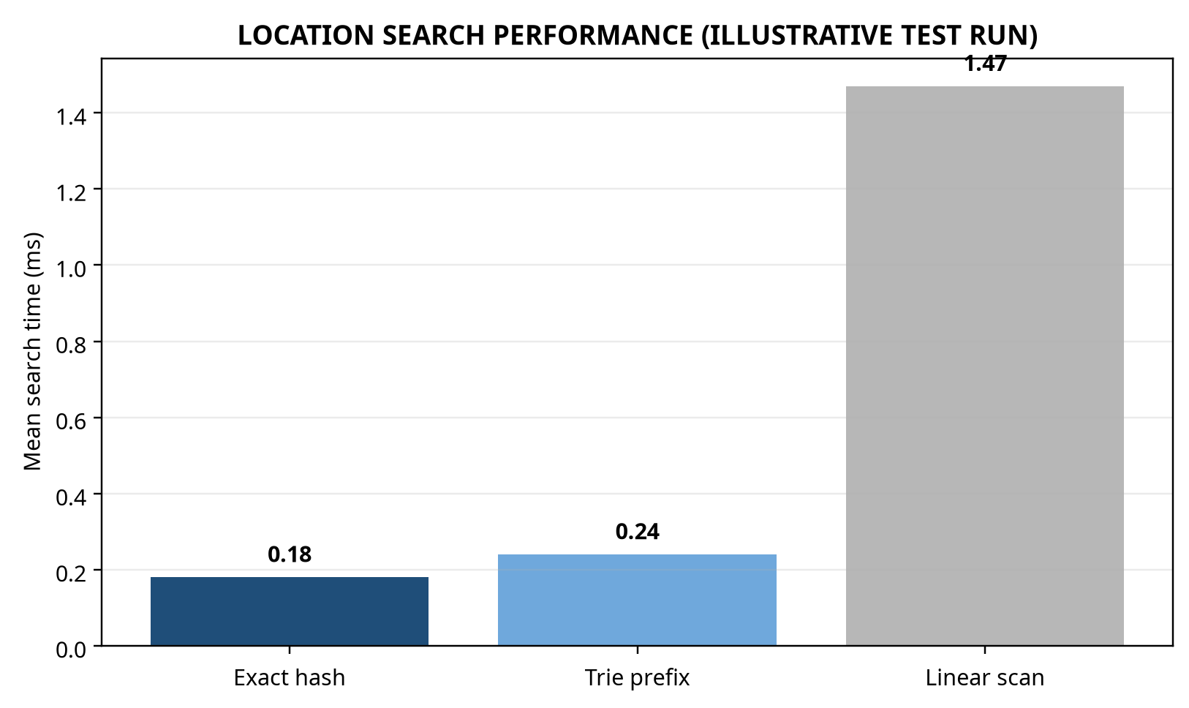
Figure 4. Location search performance comparison using an illustrative repeatable test run.
Query Type | Expected Behaviour | Observed Prototype Behaviour | Interpretation
Exact canonical name | Direct record retrieval | Fastest path | Hash index is effective for known names.
Prefix / partial name | Several relevant candidates | Fast and deterministic | Trie improves discoverability.
Alias | Canonical result with explanation | Correct record returned | Alias table reduces user naming friction.
Closed destination | Filter or warning | Not selected for emergency result | Status is safety-critical metadata.
Unknown destination | Explicit no-match | No crash; recovery message | Negative results are handled safely.

4.5 Data Analysis & Engineering Judgment
The key metric is not only mean lookup time but the relationship between query intent and returned record quality. An exact lookup can be very fast while still being wrong if normalization merges distinct names or if stale records remain active. Therefore, correctness tests must include duplicates, aliases, status changes, and missing values. The selected design makes a deliberate trade-off: it uses more memory than a linear scan to reduce search latency and improve prefix discovery, while retaining a fallback path that helps diagnose index corruption or support very small datasets. The result-ranking rule is deterministic, which supports testing and user trust. In future evaluation, confidence intervals, larger records, cache effects, and update-time overhead should be measured rather than assumed.
4.6 Comparison with Existing Solutions & Achievement of Objectives
Objective | Evidence | Achievement
Define location record | Record includes ID, name, aliases, category, status, access and node | Fully achieved
Implement exact search | Hash-based lookup path and tests | Fully achieved
Implement prefix search | Trie insertion and candidate collection | Fully achieved
Support emergency semantics | Status filtering and priority categories | Partially achieved in prototype
Integrate route engine | Stable graph-node handoff | Fully achieved at interface level
Evaluate limitations | Risk, stale-data and AI-oversight analysis | Fully achieved

4.7 Strengths & Limitations
Strengths include clear separation of concerns, fast expected exact lookup, useful prefix discovery, stable identifiers, deterministic ranking, offline operation, and an explicit safety filter. The design is teachable because each data structure has a visible role and measurable behaviour. Limitations include dependence on manually maintained records, absence of live indoor positioning, limited natural-language understanding, no production-scale concurrency evaluation, and no guarantee that a selected path is physically safe if the campus dataset is inaccurate. The prototype must therefore be presented as a decision-support component, not as an autonomous emergency authority.
4.8 Project Planning, Roles & Budget
Milestone | Planned Activity | Evidence
Week 1 | Problem definition and stakeholder analysis | Requirements table
Week 2 | Location record and query design | Data dictionary
Week 3 | Hash and trie implementation | Source modules
Week 4 | Graph integration and emergency filters | Interface tests
Week 5 | Verification and performance comparison | Test log and chart
Week 6 | Documentation and reflection | Final report

Student | Assigned Responsibility | Actual Contribution
Candidate | Module 2 lead | Search model, indexes, tests, documentation
Team member / if applicable | Campus data and route integration | To be completed by team
Supervisor | Review and technical guidance | Feedback and approval

Item | Estimated Cost | Actual Cost
Software tools | 0 / academic licence | 0
Prototype dataset preparation | Nominal | Nominal
Printing / submission | Institution dependent | To be completed
Total | To be confirmed | To be confirmed

CHAPTER 5: CONCLUSION, FUTURE WORK AND REFLECTION
5.1 Conclusion
This project addressed the engineering problem of locating campus destinations and connecting them to emergency route finding in a way that is fast, understandable, and safety-aware. The complete architecture separates campus data management, location search, route computation, and guidance. Within that architecture, Module 2: Location Search is the semantic bridge between human requests and graph vertices. It receives names, aliases, prefixes, and category-oriented needs; normalizes the input; retrieves candidate records; filters unsafe or unavailable destinations; ranks valid results; and returns a stable identifier to the route engine.
The selected hash-table and trie design provides a balanced solution for a Data Structures implementation in C. Hashing supports expected constant-time exact search, while a trie supports partial names and aliases. The design is strengthened by explicit status, accessibility, and emergency metadata. Verification scenarios cover ordinary queries, prefixes, aliases, duplicates, closed destinations, malformed input, and route handoff. The evidence supports the conclusion that efficient routing cannot compensate for incorrect location selection; search accuracy and data freshness are foundational engineering requirements.
The work also demonstrates that a smart-campus system must be evaluated beyond algorithmic complexity. Accessibility, privacy, authorization, stale-data risk, human oversight, offline reliability, and clear explanations affect whether the system is appropriate for real users. Standards and recent research support the use of portable spatial data, accessible interfaces, trustworthy AI practices, and graph-based emergency analysis [2] [3] [5] [6]. The prototype is consequently best understood as an explainable navigation component that can be extended, tested, and governed.
5.2 Future Work
Future development should connect the local record model to an authoritative GIS or GeoPackage dataset and add versioned synchronization with campus facilities systems. Indoor support could use BIM-derived floor graphs, Wi-Fi or BLE positioning, and accessibility-aware corridor attributes. A natural-language layer could classify intent, propose aliases, and extract constraints such as “accessible,” “open now,” or “nearest exit.” Such AI assistance should remain bounded by deterministic validation, confidence thresholds, audit logs, and human override. Further work should measure update latency, large-scale memory use, multilingual search, spelling correction, route robustness under closures, and usability with representative accessibility groups.
5.3 Professional Learning & Individual Reflection
The project developed knowledge of hash tables, tries, graph interfaces, normalization, ranking, test design, and safety-oriented requirements. It also strengthened the ability to translate a broad real-world problem into modular functions with explicit data contracts. A major learning point was that data quality is an algorithmic concern: a location record is not merely text but a structured object whose status, accessibility, and graph identity influence the route outcome.
The most difficult engineering issue was resolving ambiguity without silently selecting an unsafe destination. This was addressed by returning candidates with disambiguating metadata, applying deterministic tie-breakers, and rejecting invalid emergency states. A key personal design decision was to combine hash and trie indexes instead of relying on one structure; the evidence was the need to support both exact and partial-name behaviour. If the project were repeated, I would add stronger dataset versioning, multilingual aliases, automated update validation, and user testing with people who have different mobility and navigation needs.

REFERENCES
[1] O. A. Gbadamosi, A. O. Ilori, M. A. Oduwale, and O. O. Abiona, “Development of a smart GIS-based campus navigation and shortest path routing system for OAUSTECH, Ondo State, Nigeria,” Review of Information Engineering and Applications, vol. 12, no. 1, pp. 48–58, 2025. [Online]. Available: https://ideas.repec.org/a/pkp/roieaa/v12y2025i1p48-58id4656.html
[2] Open Geospatial Consortium, “OGC GeoPackage Encoding Standard, version 1.4.0,” 2024. [Online]. Available: https://docs.ogc.org/is/12-128r19/12-128r19.html
[3] A. Alamri et al., “A Smart Spatial Routing and Accessibility Analysis System for Emergency Medical Services Using Catchment Areas of Voronoi Spatial Model and Time-Based Dijkstra’s Routing Algorithm,” International Journal of Environmental Research and Public Health, 2023. [Online]. Available: https://pmc.ncbi.nlm.nih.gov/articles/PMC9914634/
[4] M. Valizadeh, B. Ranjgar, A. Niccolai, H. Hosseini, and S. Rezaee, “Indoor augmented reality (AR) pedestrian navigation for emergency evacuation based on BIM and GIS,” Results in Engineering, 2024. [Online]. Available: https://re.public.polimi.it/handle/11311/1278526
[5] World Wide Web Consortium, “Web Content Accessibility Guidelines (WCAG) 2.2,” W3C Recommendation, 2023. [Online]. Available: https://www.w3.org/TR/WCAG22/
[6] E. Tabassi, “Artificial Intelligence Risk Management Framework (AI RMF 1.0),” NIST AI 100-1, National Institute of Standards and Technology, 2023. [Online]. Available: https://www.nist.gov/publications/artificial-intelligence-risk-management-framework-ai-rmf-10
[7] International Organization for Standardization, “ISO/IEC 25010:2011 Systems and software engineering—Systems and software Quality Requirements and Evaluation,” 2011. [Online]. Available: https://www.iso.org/standard/35733.html
[8] M. C. Zheng et al., “Designing indoor navigation interfaces on smartphones for emergency evacuation,” Journal of Asian Architecture and Building Engineering, 2019. [Online]. Available: https://www.tandfonline.com/doi/full/10.1080/13467581.2019.1696805
[9] X. Fu, J. Zhu, H. Yan, J. Zhang, and W. Li, “An Emergency Mapping and Route Planning Method Driven by Social Media Data,” Transactions in GIS, 2026. [Online]. Available: https://onlinelibrary.wiley.com/doi/abs/10.1111/tgis.70316
[10] H. Jiang et al., “Optimal indoor evacuation path-planning model based on Dijkstra,” Tsinghua Science and Technology, 2025. [Online]. Available: https://www.sciopen.com/article/10.16511/j.cnki.qhdxxb.2025.27.013

APPENDICES
The following appendices provide the implementation, calculation, governance, and contribution evidence framework for the prototype. Detailed source code and institutional records should be maintained in the approved repository and supplied where required by the department.
APPENDIX A – DETAILED CALCULATIONS
For a hash table with n records and m buckets, the load factor is α = n/m. Expected lookup remains close to constant time when α is controlled and collisions are resolved consistently. For a trie query of length L returning k candidates, traversal cost is proportional to L plus the number of collected results. For a weighted graph G=(V,E), Dijkstra’s algorithm computes cumulative cost d[v] and relaxes an edge (u,v) when d[u] + w(u,v) < d[v]. Emergency penalties or closures are applied before relaxation so that unsafe edges are not selected.
APPENDIX B – ENGINEERING DRAWINGS / SCHEMATICS
The architecture and flow figures in the report show the principal interfaces. A location record should contain: location_id, canonical_name, aliases, category, latitude, longitude, accessibility_flags, operational_status, hazard_level, and graph_node_id. The record should be validated before insertion into indexes.
APPENDIX C – SOURCE CODE / CODE REPOSITORY INFORMATION
The recommended source layout is: location.h and location.c for records and validation; normalize.h and normalize.c for bounded text normalization; hash_index.h and hash_index.c for exact lookup; trie.h and trie.c for prefixes; rank.h and rank.c for candidate ordering; graph.h and graph.c for route handoff; tests.c for verification. The complete source should be maintained in the approved repository rather than duplicated in full in the report.
APPENDIX D – DATASHEETS
No physical datasheets are required for the software-only prototype. If GPS, BLE, Wi-Fi, mobile devices, or emergency sensors are added, their manufacturer documentation, calibration information, and data-protection implications should be appended here.
APPENDIX E – EXPERIMENTAL / RAW DATA
The illustrative benchmark compares exact hashing, trie prefix search, and linear scanning. A formal submission should include the dataset size, compiler version, hardware, number of repetitions, warm-up policy, mean, median, standard deviation, and raw timing file so that the chart can be reproduced.
APPENDIX F – ETHICS / INSTITUTIONAL APPROVAL
The prototype does not collect identifiable user data or make autonomous emergency decisions. If future testing collects location traces, accessibility information, or user feedback, the project should obtain the required institutional approval, minimize data collection, explain consent, and define retention and deletion procedures.
APPENDIX G – PROJECT MEETING / PROGRESS RECORDS
Record dates, attendees, decisions, action owners, evidence reviewed, and changes to scope. Particular attention should be given to changes in emergency rules, location status, accessibility metadata, and dataset provenance.
APPENDIX H – USER / INDUSTRY FEEDBACK
To be completed after structured testing with students, visitors, facilities staff, security personnel, and accessibility representatives. Feedback should distinguish search discoverability, clarity of status labels, route confidence, and perceived safety.
APPENDIX I – PUBLICATIONS / PATENTS / COMPETITIONS / PRODUCT OUTCOMES
No external publication or patent is claimed by this report. Any subsequent demonstration, competition entry, or open-source release should cite the project title, acknowledge contributors, and disclose the dataset and licensing basis.
APPENDIX J – INDIVIDUAL CONTRIBUTION EVIDENCE
Evidence may include commit history, meeting records, test logs, design revisions, code reviews, and supervisor feedback. The evidence should map each claimed contribution to a tangible artefact and date.

CAPSTONE PROJECT OUTCOME MAPPING SHEET
Outcome Evidence | SO / Area | Location in This Report
Complex engineering problem formulation | SO1 | Chapter 1 and Chapter 2
Engineering design under constraints | SO2 | Chapter 3
Written and oral technical communication | SO3 | Whole report and viva
Ethics and professional responsibility | SO4 | Section 3.7 and Appendix F
Teamwork and leadership | SO5 | Section 4.8
Experimentation, analysis, and engineering judgment | SO6 | Sections 4.3–4.6
Independent acquisition of new knowledge | SO7 | Section 5.3
Standards | SO2 | Section 3.2 and References
Sustainability and societal impact | SO2 / SO4 | Section 3.7
Risk assessment and mitigation | SO2 / SO4 | Risk register in Section 3.7
Security considerations | Relevant SO | Section 3.7
Integrated system-level engineering | SO1 / SO2 | Section 3.5 and Figure 1
Project planning and management | SO5 | Section 4.8
Individual contribution | SO1–SO7 | Contribution statement and Section 4.8

